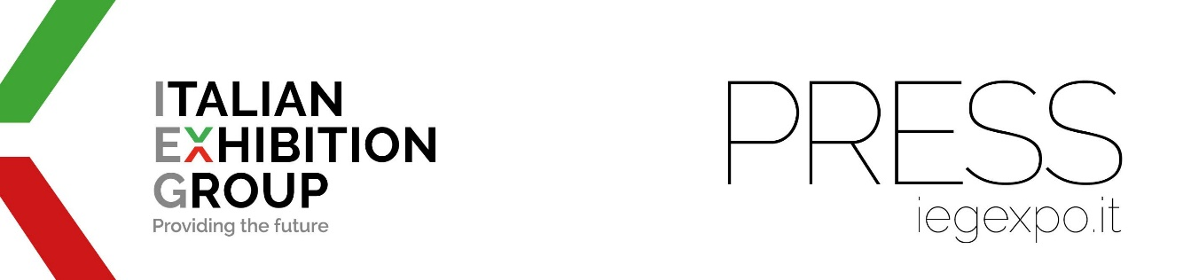

press release
(English translation)

IEG CONSOLIDATES ITS LINK WITH ASIAN MARKETS

- From tomorrow in Singapore, the food&beverage and equipment shows;
in July, the appointment with luxury
- Cicero: “Singapore business hub: the world’s second port
connected to 600 others in 123 countries on 6 continents”

Rimini (Italy), 24th May 2023 – From China to the Middle East. Having just successfully concluded the first edition of SIGEP China in Shenzhen, in partnership with Koelnmesse and held at the same time as Anufood China, from tomorrow, 25th May, Italian Exhibition Group (IEG), will open the food&beverage and equipment shows in Singapore with IEG ASIA while the jewelry world awaits its turn in July.
“With IEG ASIA, we are fully operational on the shows we acquired last February,” explains Corrado Peraboni, CEO of IEG. “We are aiming for results both on food&beverage and catering equipment, and on jewellery, thanks to the expertise of our Sigep and Vicenzaoro trade shows, the strategic nature of the Singapore hub, and the prestigious scenario coordinated by the Singapore Tourism Board. With IEG ASIA, we will also favor the attendance of customers and the public from ASEAN countries at our events in Rimini and Vicenza, with business spin-offs in the respective territories.”

THE THREE SIMULTANEOUS FOOD EVENTS IN SINGAPORE

Starting tomorrow and for three days, Cafe Asia, International Coffee & Tea Industry Expo, Sweet & Bakes Asia and Restaurant Asia will be inaugurated at the Marina Bay Sands Expo & Convention Centre with 243 brands on display from 26 countries, followed by IEG's Food & Beverage Division, led by group brand manager Flavia Morelli.

THE JEWELLERY EVENT IN JULY

From 13th to 16th July, Singapore will also host SIJE - Singapore International Jewelry Expo 2023, followed by the Jewelry&Fashion Division IEG with global exhibition director Marco Carniello: 223 brands from 26 countries will be exhibiting.

THE ASEAN ECONOMY

“Located in the center of South-East Asia,” says Ilaria Cicero, CEO of IEG Asia Pte. Ltd., “Singapore is the main trading platform and the most important economic hub in the whole ASEAN region. Its port is the second largest in the world in terms of total shipping tonnage and is connected to over 600 other ports in 123 countries on 6 continents. Starting from this city-state, with its new company IEG ASIA, IEG aims to promote the business of Italian companies in this vast region so that they can export their products and their world-famous "Made in Italy" know-how all over the globe.”

“In the Group's international expansion strategy of the last three years,” adds Francesco Santa, CEO IEG Middle East, Dubai & international business development director IEG Group, “ASEAN represents one of the most interesting markets with about 600 million inhabitants and a GDP with one of the highest annual growth rates in the world. Singapore is the hub of the ASEAN area: that is precisely why we have acquired exhibition products in the historical sectors of IEG's Food & Beverage and Gold & Jewelry trade shows. But the objective goes even further: we aim to develop new events in Thailand, Malaysia, Vietnam, Indonesia and the Philippines, covering the key ASEAN markets with our leading exhibitions.”

PRESS CONTACT ITALIAN EXHIBITION GROUP | media@iegexpo.it
head of corporate communication & media relations: Elisabetta Vitali|
press office manager: Marco Forcellini | international press office coordinator: Silvia Giorgi

This press release contains forecast elements and estimates that reflect the management’s current opinions (“forward-looking statements”), particularly regarding future management performance, realization of investments, cash flow trends and the evolution of the financial structure. For their very nature, forward-looking statements have a component of risk and uncertainty, as they depend on the occurrence of future events. The effective results may differ (even significantly) from those announced, due to numerous factors, including, only by way of example: food service market and tourist flow trends in Italy, gold and jewellery market trends, green economy market trends; the evolution of raw material prices; general macroeconomic conditions; geopolitical factors and evolutions in the legislative framework. Moreover, the information contained in this release does not claim to be complete, and has not been verified by independent third parties. Forecasts, estimates and objectives contained herein are based on the information available to the Company as at the date of this release.

